# CONTAINERIZING A PYTHON APPLICATION WITH DOCKER: DEPLOYING PYTHON IN DOCKER WITH FLASK

**Step 1: Write Your Python Application Code**

1. **Create a Python script** called app.py with the following content:

# app.py

print("Python Application using Docker!")

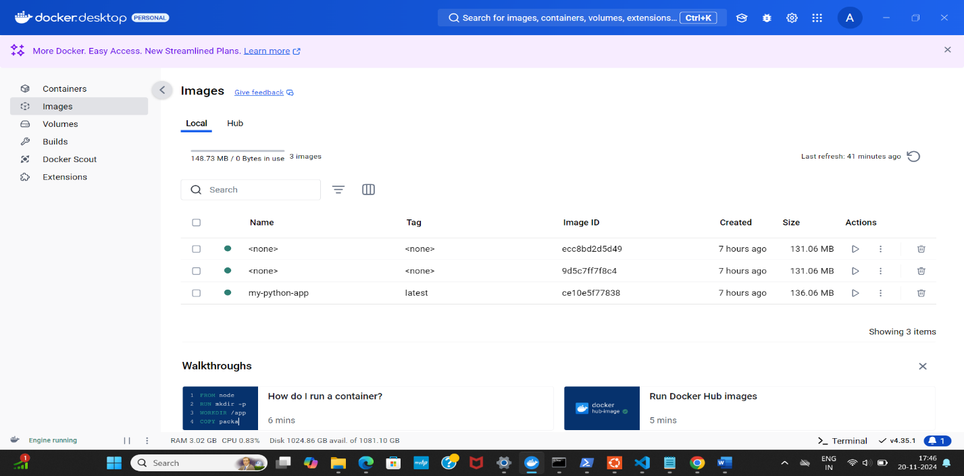

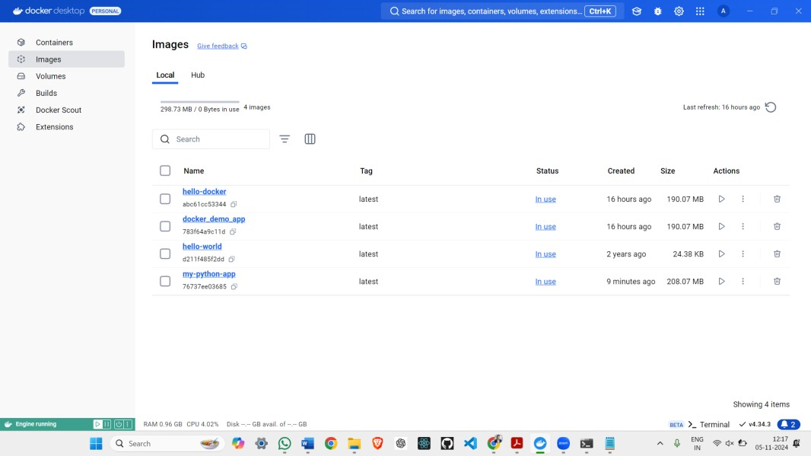

# Step 2: Create a Dockerfile

* 1. Create a file named Dockerfile in the same directory as app.py. This file contains instructions for Docker to set up the environment for the Python application:

# Use an official Python runtime as a parent image FROM python:3.8-slim

# Set the working directory in the container WORKDIR /app

# Copy the current directory contents into the container at /app COPY . /app

# Install any needed packages specified in requirements.txt # (Skip this step if no external packages are needed)

RUN pip install --trusted-host pypi.python.org -r requirements.txt || true # Make port 80 available to the outside world

EXPOSE 80

# Define environment variable ENV NAME World

# Run app.py when the container launches CMD ["python", "app.py"]

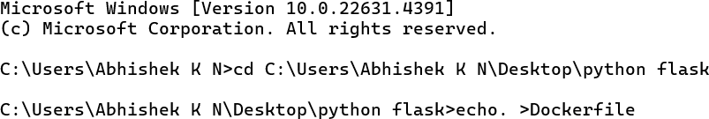

# Step 3: Build the Docker Image

1. Run the container with the following command:

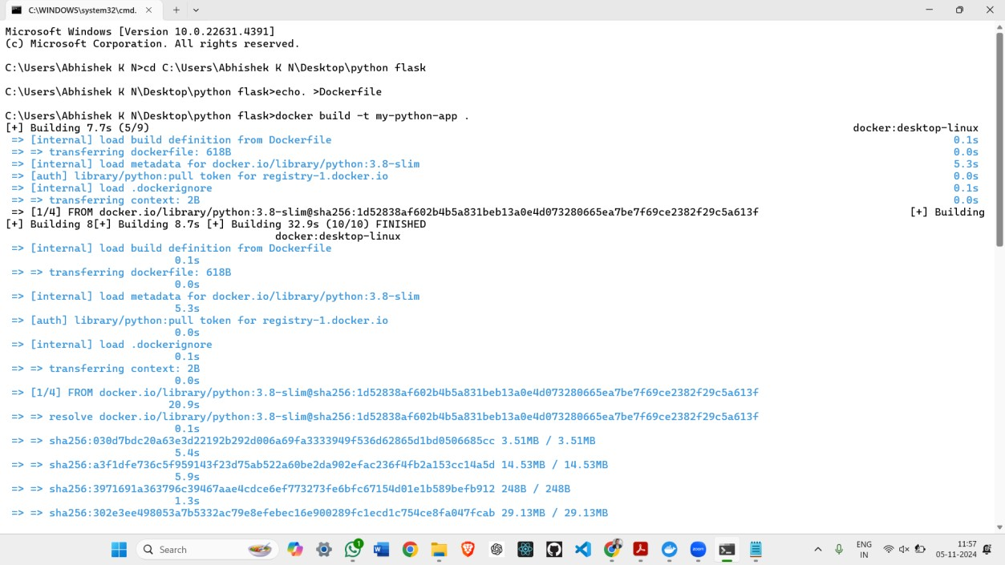

1. Build the image with the following command, replacing my-python-app with your preferred image name:

docker build -t my-python-app .

This command tells Docker to build an image using the Dockerfile in the current directory (.) and tag it as my-python-app.

**Step 4: Run the Docker Container**

bash

Copy code

docker run -p 4000:80 my-python-app This command:

o Maps port 4000 on your machine to port 80 in the container.

o Starts the container and runs app.py, which will print "Python Application using Docker!".



# Step 5: Access Your Python Application

Since app.py simply prints text to the console and doesn’t start a web server, there won’t be anything to interact with at http://localhost:4000. To create a web-based application, you’ll need to use a Python web framework like Flask.

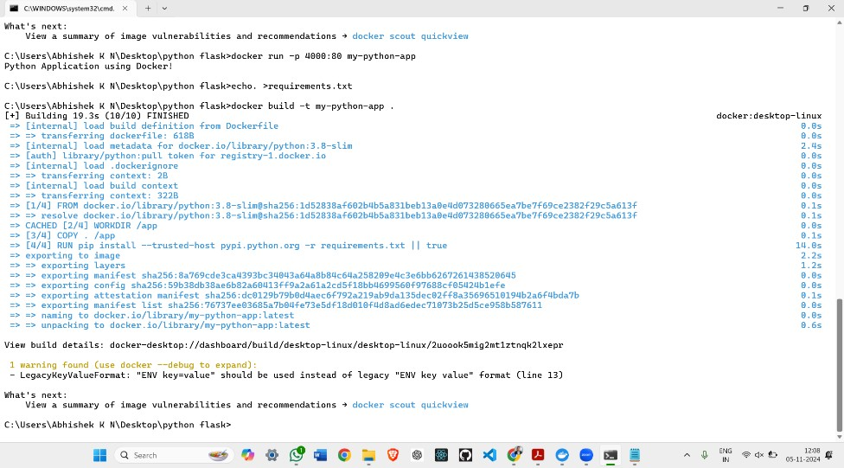

To display the message in a web browser, follow these steps:

1. **Install Flask** by creating a requirements.txt file with this line: Copy code

Flask

1. **Update app.py** to create a simple web server: python

Copy code # app.py

from flask import Flask app = Flask( name )

@app.route("/") def hello():

return "Python Application using Docker!"

if name == " main ": app.run(host="0.0.0.0", port=80)

1. **Rebuild the Docker Image** (after modifying app.py and requirements.txt): docker build -t my-python-app .

# 4 Run the Container Again:

docker run -p 4000:80 my-python-app

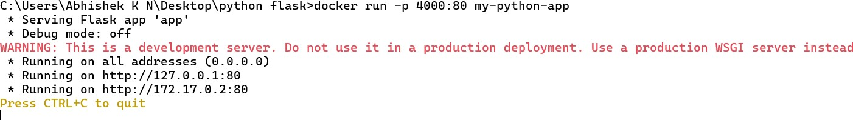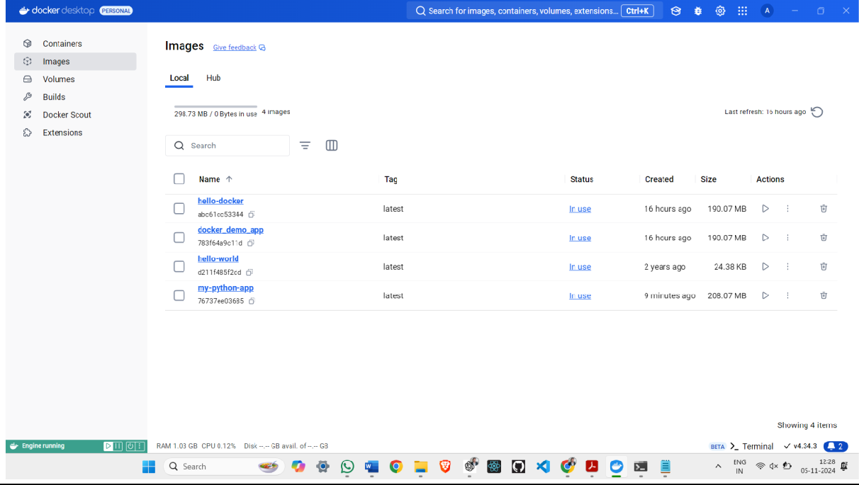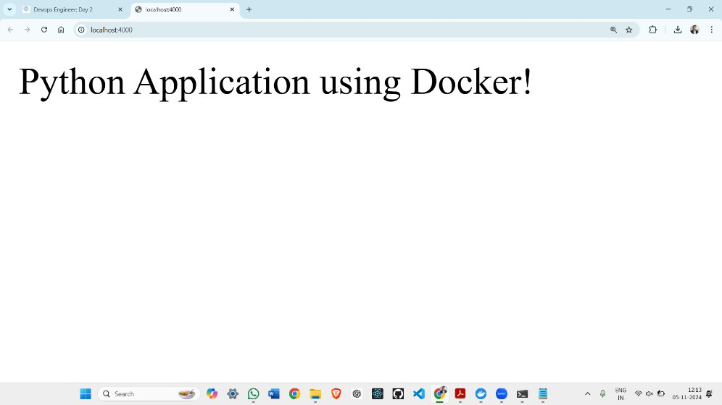

5.Access the Application by visiting http://localhost:4000 in a browser, where you should now see "Python Application using Docker!".

This setup will give you a simple Flask web application running in Docker, accessible via your browser.